Multiple choice section

Question 1 [8.2]

An angle of size 17° is called:

A obtuse B acute C reflex D straight

Question 2 [8.2]

What is the name given to a 101° angle?

A obtuse B acute C reflex D straight

Question 3 [8.2]

Which pairs of angles are complementary?

A 80° and 20° B 150° and 30° C 2° and 8° D 35° and 55°

Question 4 [8.6]

Which is true for all equilateral triangles?

A All 3 angles sum to 380°

B Only two sides are equal

C All 3 sides are different in length

D All 3 sides are equal in length

Question 5 [8.3]

What is the value of the angle x?

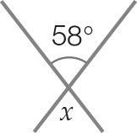

A 48° B 32° C 58° D 42°

Question 6 [8.5]

This shape is best described as a

A convex quadrilateral

B concave quadrilateral

C obtuse quadrilateral

D non-equilateral quadrilateral

Question 7 [8.4]

State which pair of angles is co-interior?

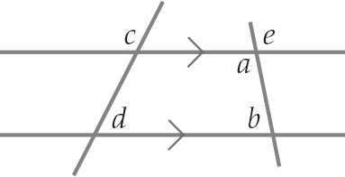

A b and e B a and b C a and c D e and d

Question 8 [8.6]

What sort of triangle is shown below?

A equilateral B isosceles C obtuse angled D scalene

Question 9 [8.5]

This polygon is called a:

A hexagon B heptagon C dodecagon D octagon

Question 10 [8.4]

What is the value of the angle y?

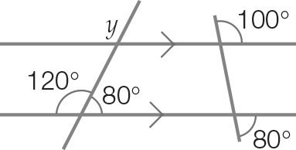

A 120° B 100° C 80° D 60°

Multiple-choice total marks: ______ / 10

Short answer section

Question 11 1 marks [8.1]

What size angle has been marked on the protractor?

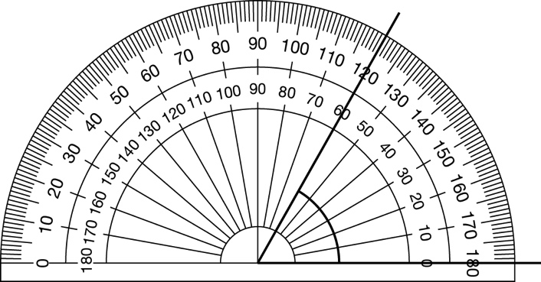

Question 12 2 marks [8.1]

Use a protractor to measure the size of the following angles, correct to the nearest degree.

(a) 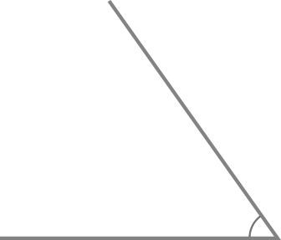 (b) 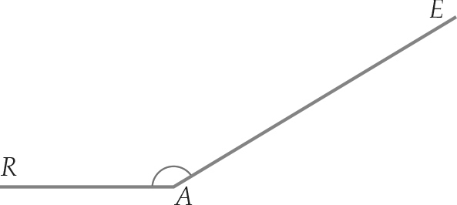

(c) One way the angle in Question 12 part **(b)** above can be named is ∠RAE.   
Name one other way of naming the same angle. __________________

Question 13 4 marks [8.1]

Draw the following angles using a protractor. The start point has been provided

(a) 34°

(b) 147°

Question 14 3 marks [8.2]

State whether the following angles are acute, right-angled, obtuse, straight angle, reflex or a revolution.

|  |  |  |
| --- | --- | --- |
| (a)    _______________________ | (b)    _______________________ | (c)  Macintosh HD:Users:lizwaud:Desktop:Screen Shot 2016-10-11 at 2.57.44 pm.png  _______________________ |

Question 15 3 marks [8.2]

State whether the following angles are acute, right-angled, obtuse or straight, reflex or revolution angles.

(a) 90° _______________________

(b) 172° ______________________

(c) 266° _______________________

Question 16 3 marks [8.2]

For each pair of angles, state whether they are complementary angles, supplementary angles or neither.

(a) 3° and 87° _______________________

(b) 105° and 85° _______________________

(c) 180° and 80° _______________________

Question 17 3 marks [8.3]

Find the size of the angle x.

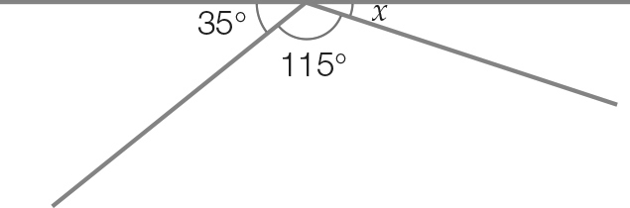

Question 18 3 marks [8.3]

Find the size of the angle x.

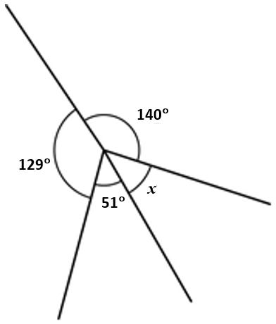

Question 19 1 marks [8.4]

On the following diagrams mark in an angle corresponding to the one shown.

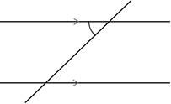

Question 20 2 marks [8.4]

Find the size of the angle marked x, giving reasons.

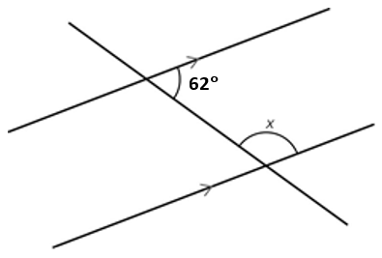

Question 21 4 marks [8.5]

Name the polygons in this pattern.

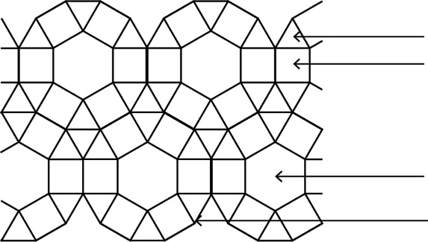

Tr_________________________

Sq________________________

Hex_________________________

Dode_________________________

Question 22 4 marks [8.6]

Find the size of the missing angle.

(a)

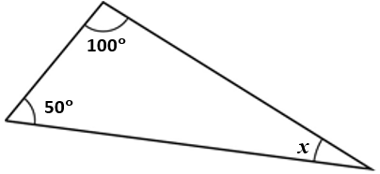

(b)

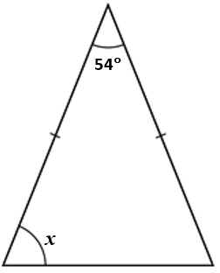

Question 23 2 marks [8.6]

Calculate the value of the exterior angle.

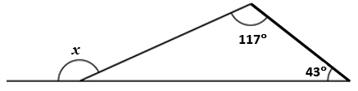

Question 24 3 marks [8.8]

Using a compass, a ruler and a pencil, draw a line that bisects the angle shown below.

Leave all construction lines.

Question 25 3 marks [8.5]

Using a ruler and a pencil draw a horizontal line that is 7.5 cm. Using your compass, ruler and pencil construct a perpendicular bisector of the 7.5 cm line you have just drawn. Leave all construction lines.

Short answer total:_______ /41

Extended answer section

Question 26 5 marks [8.7]

A kite has a top angle measuring 119° and a bottom angle measuring 21°.

(a) Draw a diagram of the kite. The diagram does not need to be to scale, but it must show the 119° angle and the 21° angle.

(b) Find the size of the other two angles. Give reasons.

Question 27 6 marks [8.7]

Find the value of x, correct to 1 decimal place.

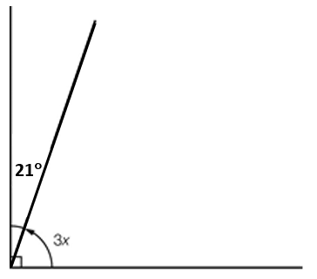

Question 28 5 marks [8.7]

The following quadrilateral has an unknown angle.

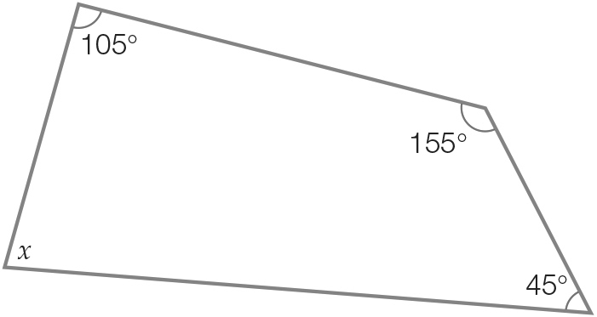

(a) Complete the following:

x + ____________ + ____________ + ____________ = 360°

(b) Simplify the above equation and solve for x.

Extended answer total:_______ /16

TOTAL test marks: _______ / 67